MyMedicalHUB

***User Manual***

|  |  |
| --- | --- |
| Document Version: | 1.1 |
| Date of Document Version: | 30/06/2022 |
| Product Version: |  |
| Date of Product Version: |  |
| Created by: | Jannatul Fardus Liza |
| Reviewed by: | Shoriful Islam |
| Approved by: | Shoriful Islam |
| Confidentiality level: | High |

**Change History**

|  |  |  |  |
| --- | --- | --- | --- |
| **Date** | **Version** | **Created by** | **Description of change** |
| 17th June 2022 | 1.0 | Jannatul Fardus Liza | Initial Drafts, Report Lock / Unlock features |
| 20th June 2022 | 1.0 | Jannatul Fardus Liza | Report Rescore Feature |
| 21st June 2022 | 1.0 | Jannatul Fardus Liza | Form Base Assessment, Biometric Assessment Question for Patient, Add Line |
| 30th June 2022 | 1.1 | Jannatul Fardus Liza | Chief Complaints New Skeleton, Merged Exercise |
|  |  |  |  |

**Table of Contents**

1. Introduction 4

2. Overview 4

3. Getting Started 4

3.1 Report Lock / Unlock Report 4

3.2 Re-score Report 6

3.3 Biometric Assessment Question for Patient 7

3.4 ADD Line on Biometric Movement BOX 8

# Introduction

This User Manual provides the information necessary for users to effectively use the System. This is a General Guideline. Any user can go through our system with this guideline. Here we have included all new features which have been implemented recently.

# Overview

Our System has 2 Portals

1. Provider
2. Patient

The Provider can do several Functionalities Like invite a Patient for Telemedicine, Self-Assessment, In Clinic Encounter, Pain log, Take Biometric Assessment, Put personal views on the Assessment Reports etc.

On the other hand, Patient can be registered to our system through the providers invitation. Patient can do self-assessment, Telemedicine, Follow-up etc. There are Some Other features as well included at Provider and Patient Portal.

For System improvements Some new feature and changed have been made. This Document has covered all the recent changes.

# Getting Started

The New features which have been implemented recently are given below:

### 3.1 Report Lock / Unlock Report

Some New Features are added on the HTML report and PDF version reports.

* This feature is only application for Provider report
* After Locking the Report, the provider cannot edit or update any fields value on the report

**Steps:**

1. Open the Assessment Report

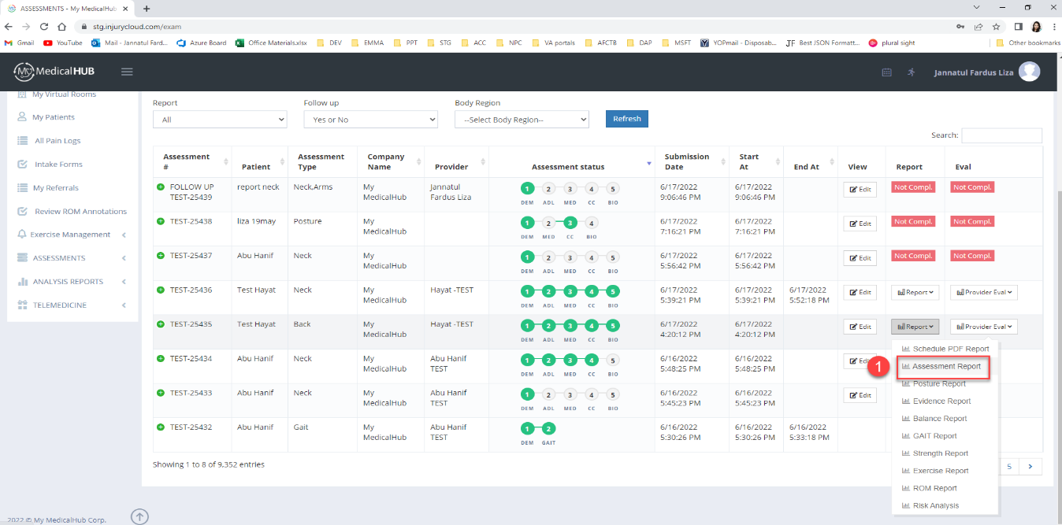

Figure: Assessment report

1. Now go to the bottom of the report

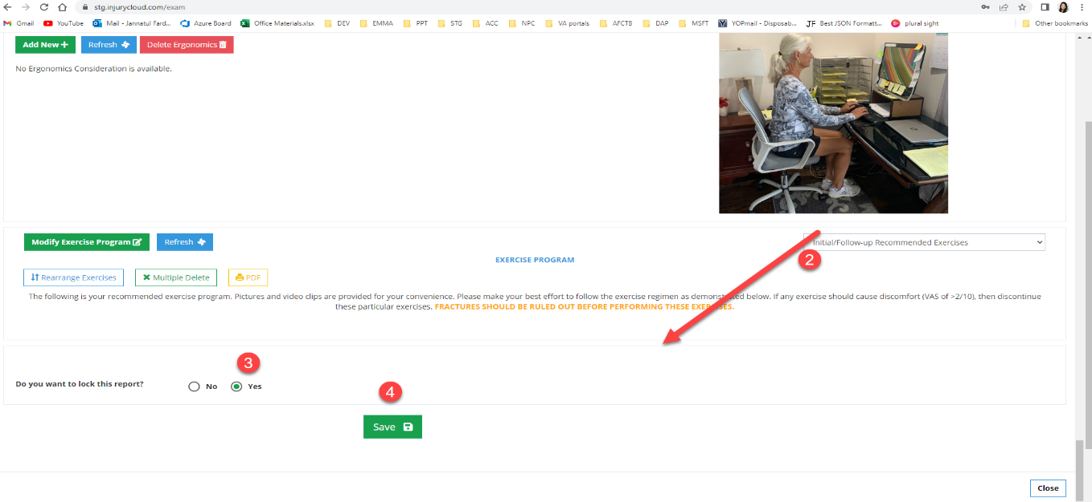

Figure: Lock Report

1. To Lock Report provider should select “Yes”
2. Now click on the “Save” Button
3. Then Close the Report and again open the assessment report
4. Now observe provider cannot edit any field
5. To unlock the report the provider should select “No”
6. Then Save the Report and then close it and reopen it to get the editing / update option again.

### 3.2 Re-score Report

This feature is implemented to re-score the report if there is a mismatch between the PDF and HTML Report.

**Pre-Condition:**

* Report must be Unlocked
* Provider should Save the New changes from HTML Report

**Steps:**

1. Click on Schedule PDF Report
2. Now click on the View button

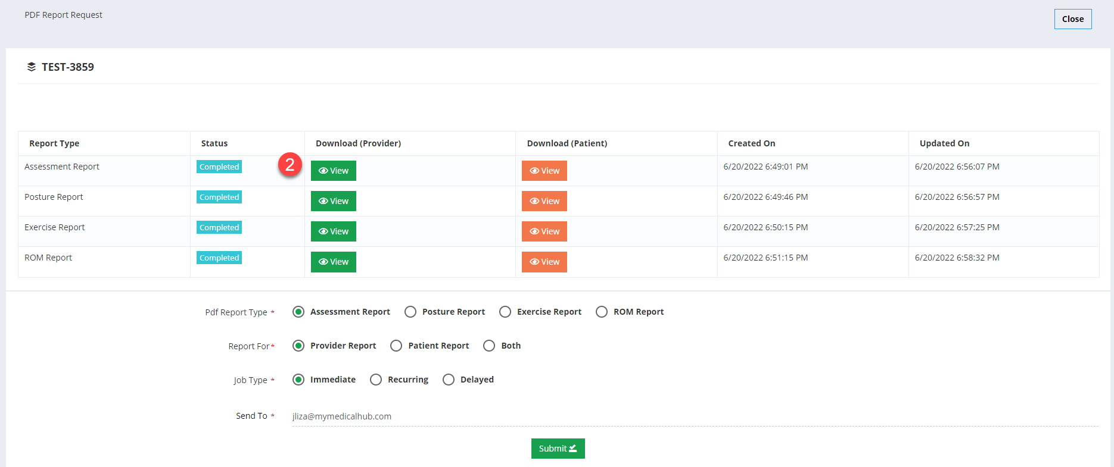

1. Then click on the Re-score button to re-score the report
2. After re-scoring the provider will get a success message

### 3.3 Biometric Assessment Question for Patient

If Patient Clicks on the Take Biometric Movements Button from My assessment page Biometric Assessment Questions Will Pop up.

Steps:

1. Login to Patient Portal
2. Go to My assessment Page

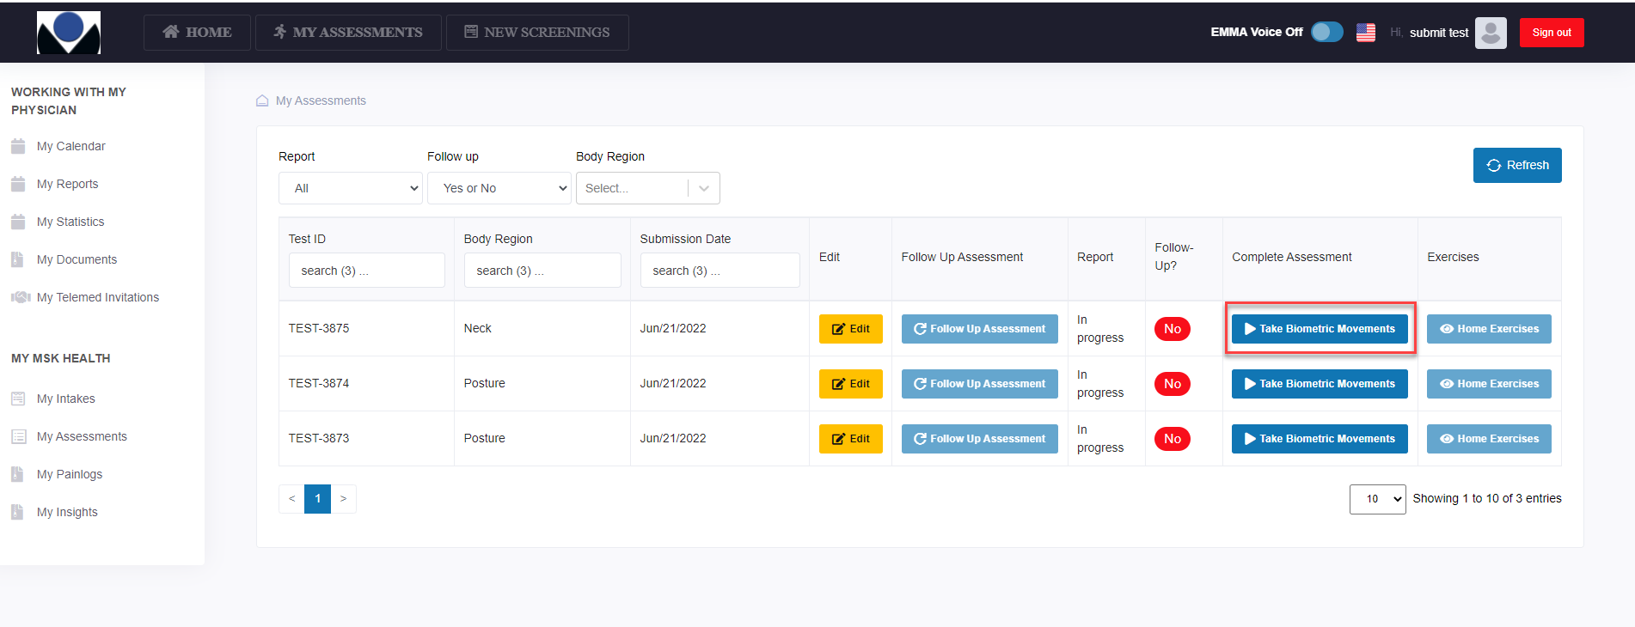

1. Now Click on the “Take Biometric Movements”

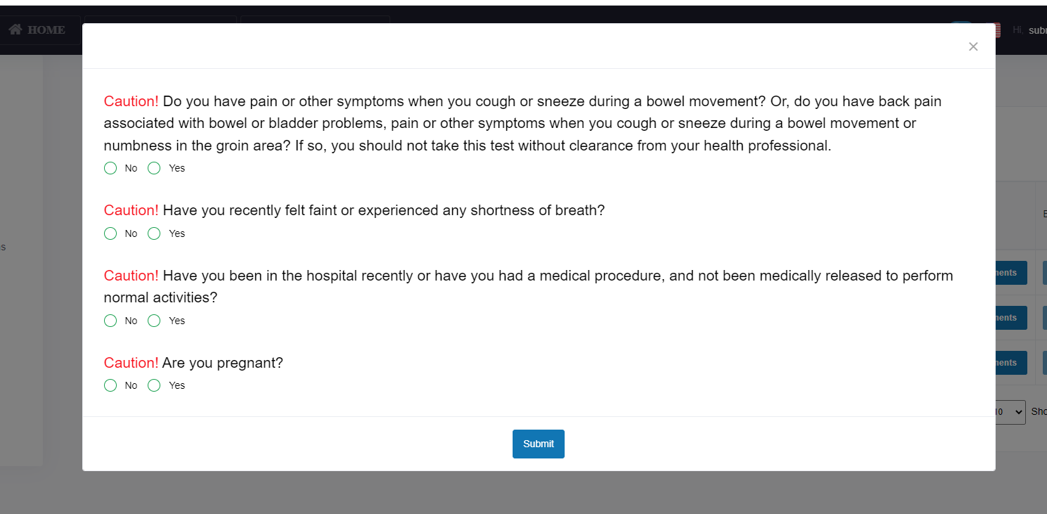

1. Now Observe Caution question arises. Now Patient have to Answer all these questions.
2. If Patient answer any question as “YES” then He will not able to do Biometric Movements and a Confirmation Alert will generates.

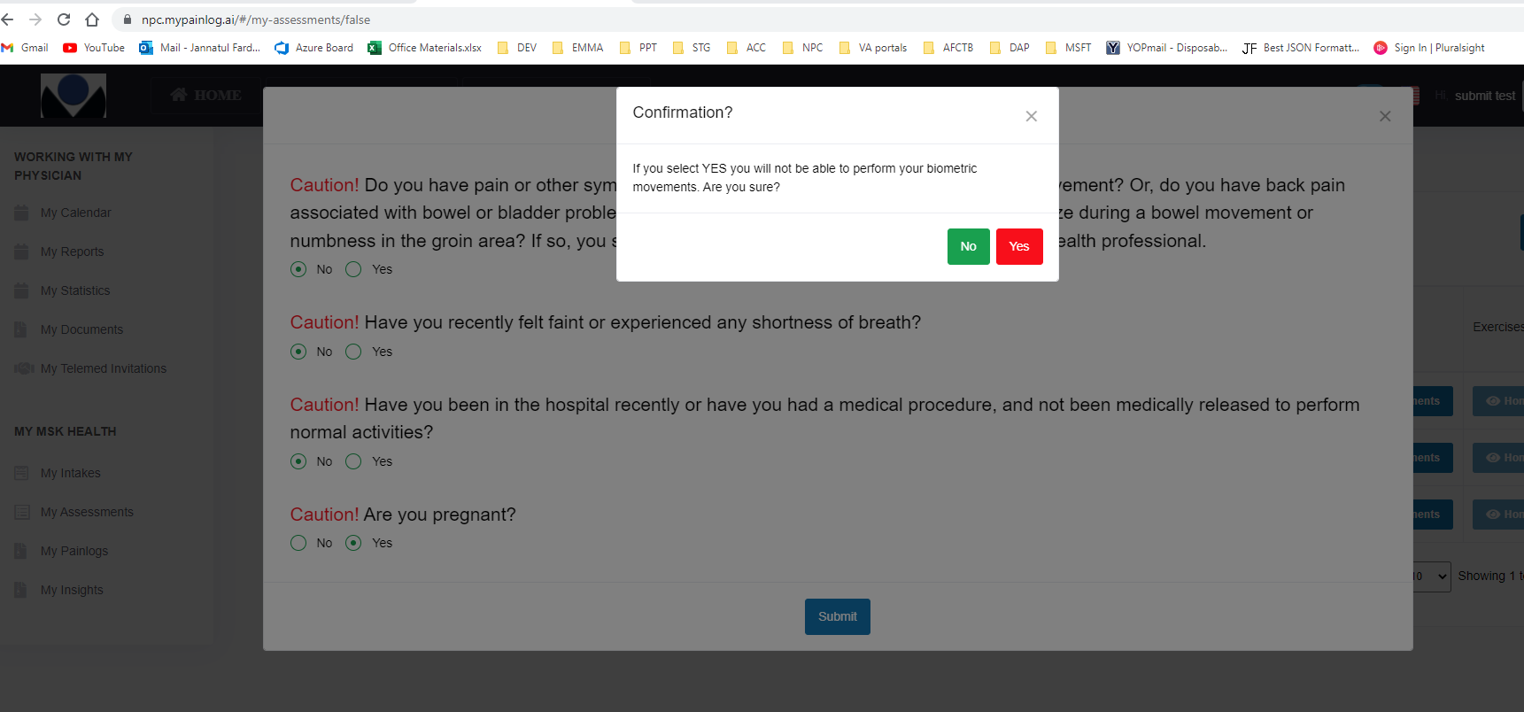

### 3.4 ADD Line on Biometric Movement BOX

On the Patient Biometric Movement BOX During Exercise an Additional line is added at the bottom. Here patients can align their toes on to ensure that right and left feet are properly placed.

Pre-Condition:

* Line will be showing during Self-Assessment
* Patient have to set Both of their Feet on the bottom line otherwise the Green Box will not appear.

Steps:

1. Login to Patient Portal
2. Go to My Assessment Page Click on the Take Biometric Movements Button
3. Now when the Biometric Movement BOX appear patients have to align their toes on to Bottom line to ensure that right and left feet are properly placed.

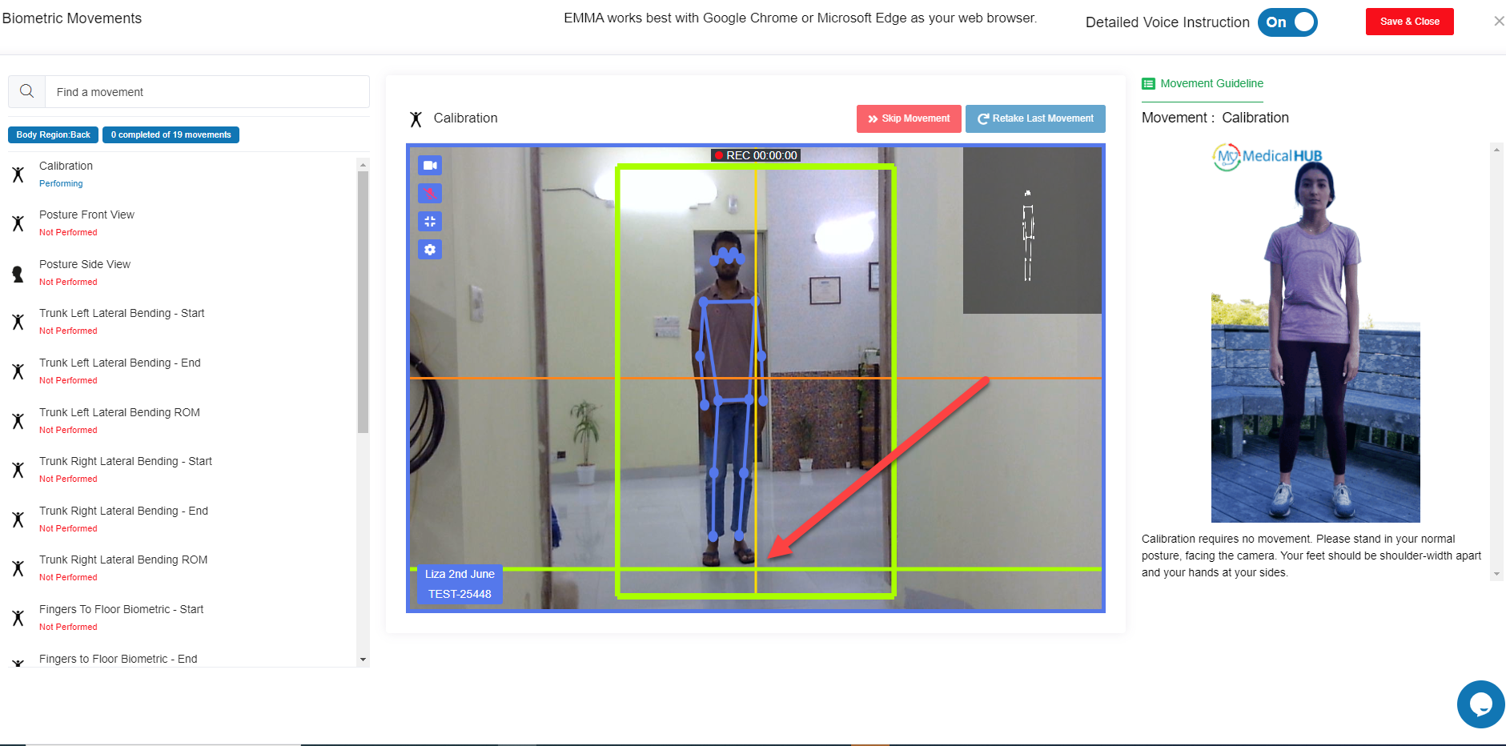

1. Then Observe Green Box is appeared

### 3.5 Patient Chief Complaints New Skeleton on BOT

A new Chief Complaints Skeleton is added on BOT. This feature is added to make the Chief Complaints effective. The Chief Complaints Diagram is same for both Patient and Provider.

**Steps:**

1. Invite a Patient for Self / Telemedicine/ In clinic / Follow-up
2. Patient stats from the patient portal notification modal
3. Now after Completing Demographic, ADL and Medical History then Patient stats Chief Complaints
4. On Chief Complaints Page Patient can see the new Skeleton Diagram

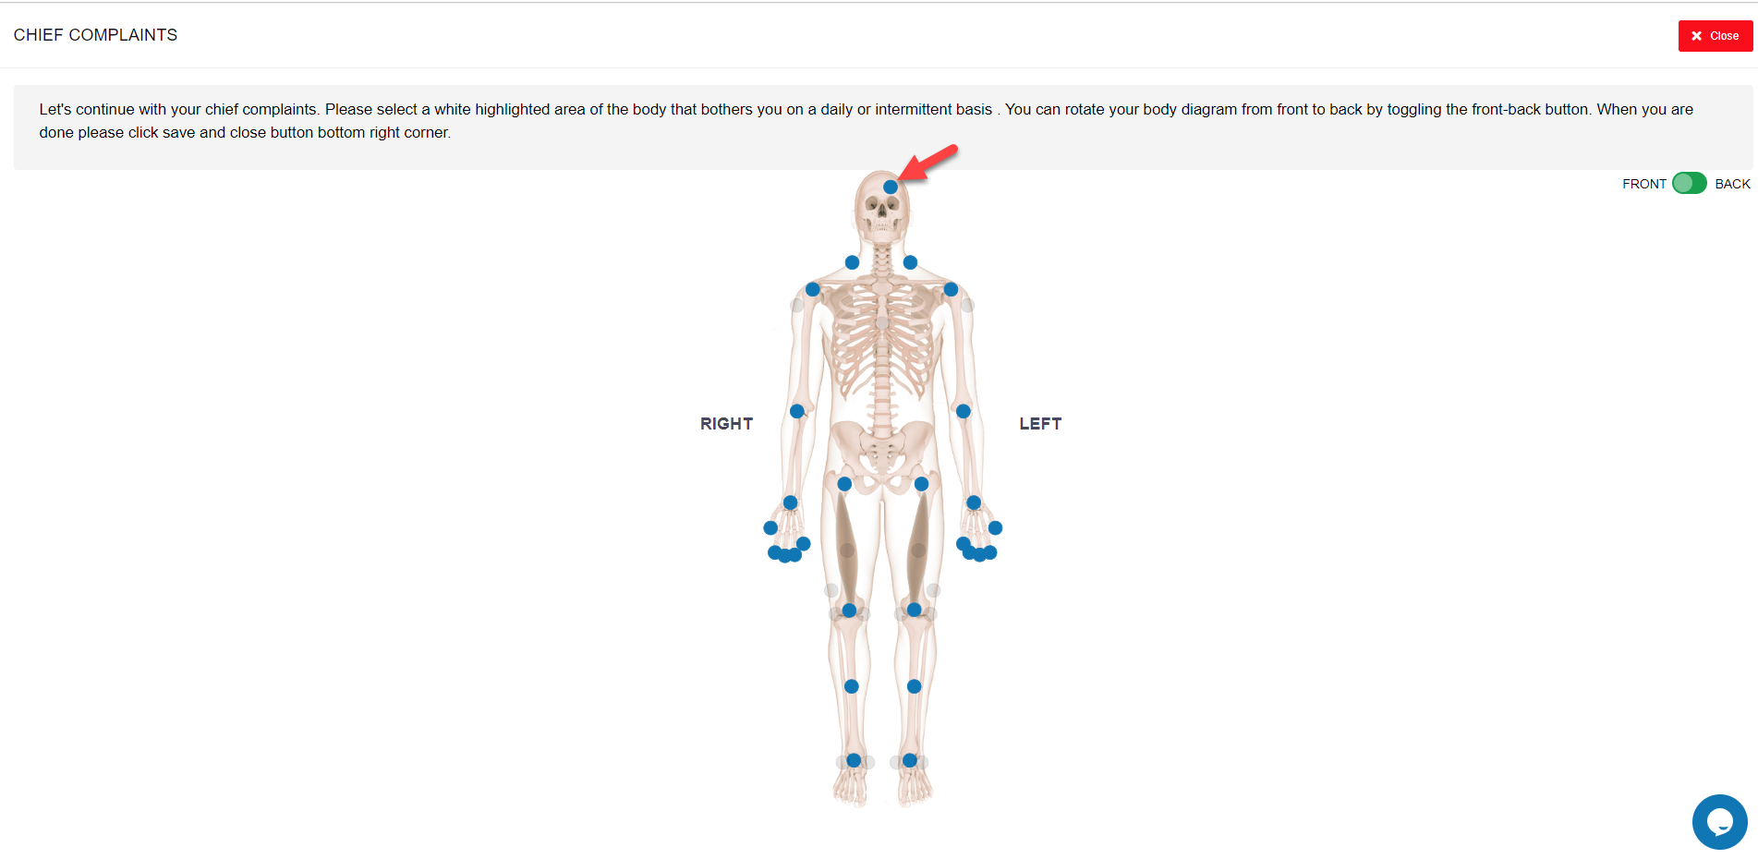

1. Now user can select the Blue marked Circle and can answer all the questions.

### 3.6 Patient Chief Complaints New Skeleton on Edit Assessment Page

From Edit Assessment Patient Can View the New Chief Complaints Diagram.

**Steps**:

1. Login to Patient Portal
2. Go to My Assessments
3. Then Click on Edit Button and go to Chief Complaints page

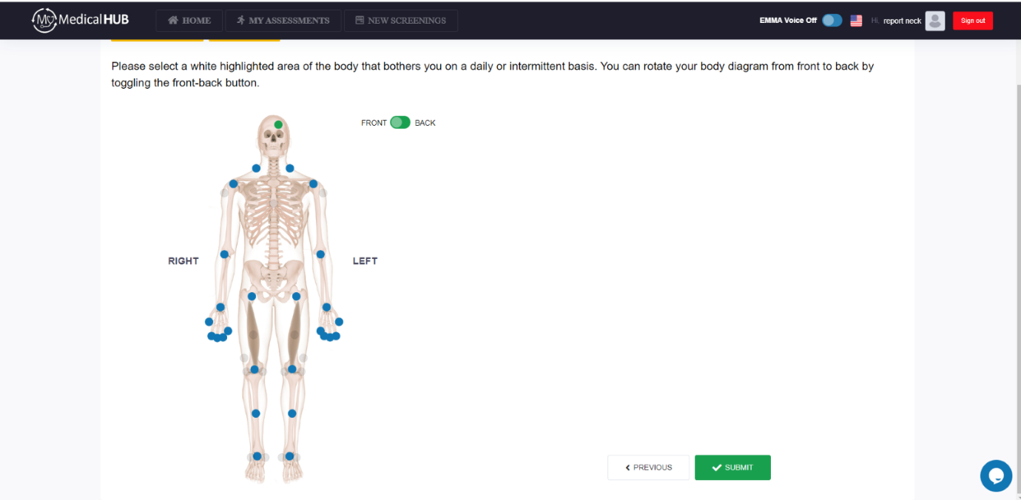

1. Now observe if patient give data for a particular body region from BOT it will highlighted and shows also from Edit Assessment page
2. From This page Patient can also add more data by selecting body regions.
3. If a patient selects a body region, then associated questions will appear

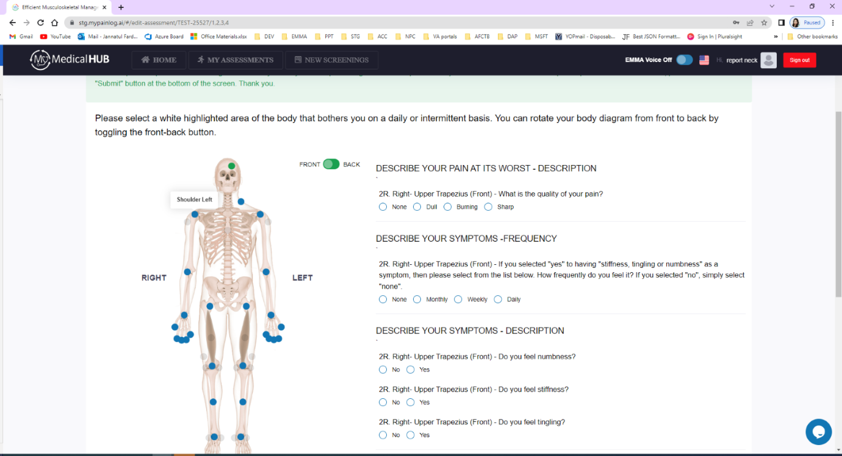

1. Patients have to answer all the questions and click on the SUBMIT button

***3.7 Merged Exercise***